MES COLLEGE PONNANI, PONNANI SOUTH

FLAMINGO NATURE CLUB

Student coordinator- Shahala Banu, I year, Dept of English

Activities
Selection Camp
10/10/2019
Flamingo Nature Club convened its first meeting on 10/10/2019 in MSK Hall at 2.00PM. More than 50 students attended the programme. Principal inaugurated the meeting. Membership registration was completed in the second session. Each Members introduced themselves to the group. Ms.Shahala Banu (Department of English) was elected as the Student coordinator of Nature club and Ms. Shahala Sherin (Department of Zoology) was elected as the joint coordinator. Future plan of action of the club was discussed.
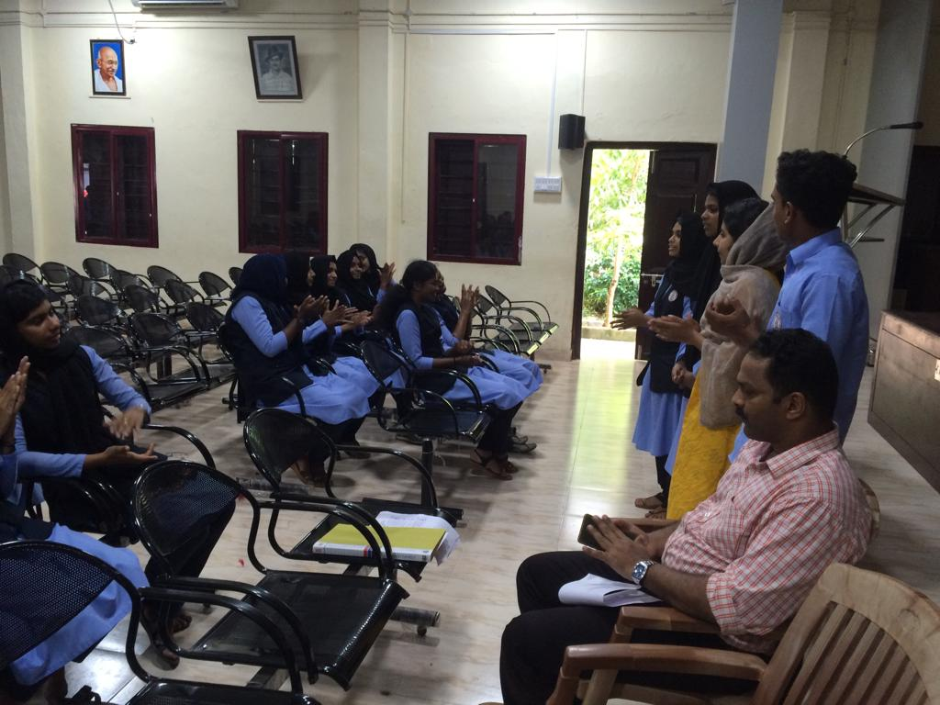 | 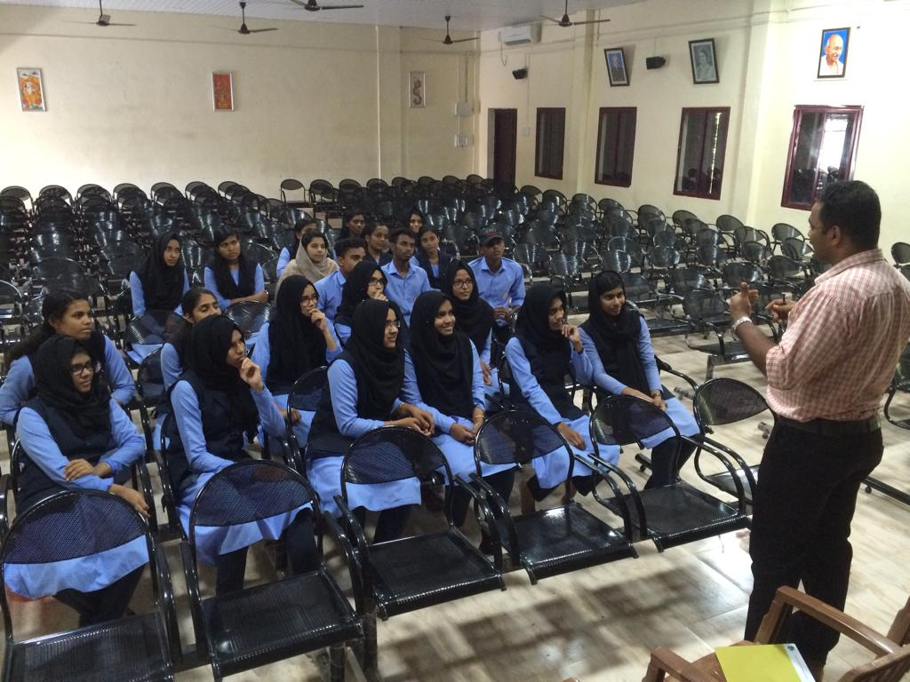
Selectrion camp for New volunteers .10-10-2019

Orientation Class-8/11/2019
A orientation class was conducted for the volunteers of Flamingo Nature Club. In which Dr. Mujeeb Rahman, Asst Professor, handled a session on the “Importance of Nature conservation and current scenario in Ponnani”. Around 40 students attended the programme.
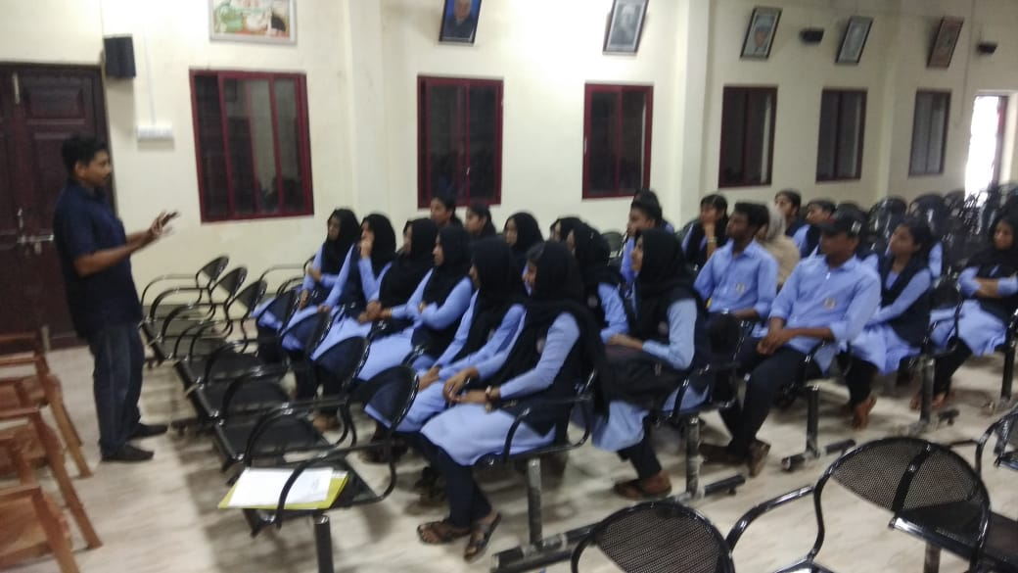
18/02/20
Members of the group participated in a one day cleaning campaign within the campus. They also planted some trees in the campus orchard near EK Auditorium.
Campus Orchard Near EK Auditorium
Nearly One acre of land area near EK Auditorium of the campus has been converted in to a green zone with varieties of trees and plants in which many of them belongs to rare species. It is fully fenced and well maintained in an elevated sandy bed adjacent to the College Football ground. Lot of vegetable plants are also being cultivated as mid crops amongst the tree plantation. Varieties of mango trees belonging to different species are a major attraction. Volunteers hailing from Flamingo Nature Club of the college look after the keep up of this green patch.
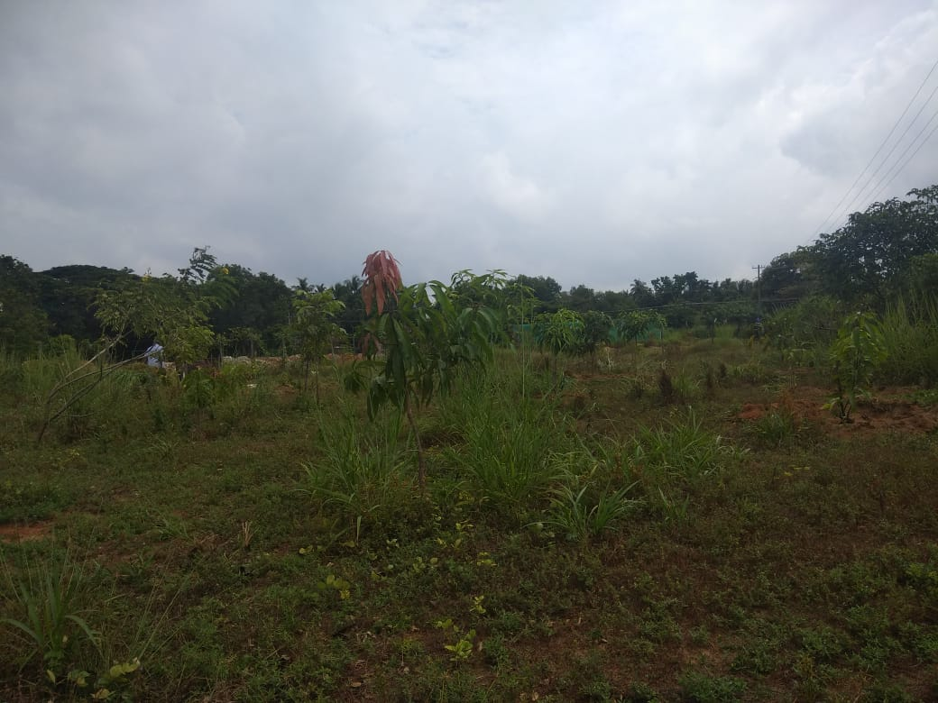 | 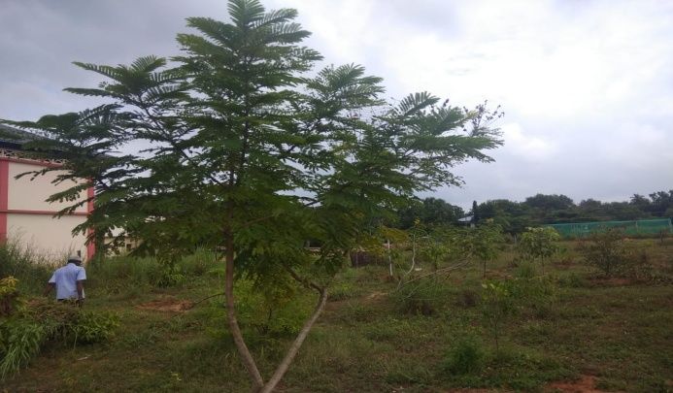
View of the New Garden being raised near EK Hall

